C868 – Software Capstone Project Summary

Task 2 – Section C

|  |  |
| --- | --- |
| Capstone Proposal Project Name: | http://www.idevnews.com/views/images/uploads/general/wgu_logo.png  CCC SAYOP Registrar – Mobile Application |
| Student Name: | Greg Westmoreland |

Table of Contents

Table of Contents 2

Task 2 Part C – C868 Software Development Capstone 4

Application Design and Testing 4

Design Document 4

Class Design 4

UI Design 6

Unit Test Plan 6

Introduction 6

Purpose 6

Overview 6

Test Plan 7

Items 7

Features 7

Deliverables 7

Tasks 7

Needs 7

Pass/Fail Criteria 7

Specifications 7

Procedures 8

Results 8

C4. Source Code 8

C5. Link to Live Version 9

User Guide 10

Introduction 10

Installation and Using the Application 10

Login and Signup (An example) 10

Classes 11

Create a New Class 11

Reports 12

Task 2 Part C – C868 Software Development Capstone

# Application Design and Testing

# Design Document

## Class Design

There are four database tables that are part of the CCC SAYOP Registrar Mobile Application Version 2. The application uses the Room Persistent Library to make all of the database queries with SQLite that will be installed on the end user’s device. The Entity Relationship Design (ERD) has been provided to show the relationship between the four database tables:

* users_table (1:1) with relationship with Users Data Access Object
* terms_table (1:1) with relationship with Terms Data Access Object
* courses_table (1:1) with relationship with Courses Data Access Object
* assessments_table (1:1) with relationship with Assessments Data Access Object
* terms_table (1:M) with relationship with the courses_table
* courses_table (1:M) with relationship with the assessments_table

There are twelve main classes that are part of the CCC SAYOP Registrar Mobile Application Version 2. These classes consist of:

* Main_Activity_Log_In_Page
* Main_Activity_Home_Page
* Reports_Page
* List_Terms
* Edit_Existing_Term
* Add_New_Term
* List_Courses
* Edit_Existing_Course
* Add_New_Course
* List Assessments
* Edit_Existing_Assessment
* Add_New_Assessment

The Main_Activity_Log_In_Page includes a log in screen for authentication using a username and password to access the application. Once logged in, the user is taken to the Main_Activity_Home_Page. The user then can select one of four options: List_Terms, List_Courses, List_Assessments, or Reports_Page.

If the user wants to view all the terms, they will select the List_Terms navigational button. From here the user can Add_A_New_Term, Edit_Existing_Term, or return to Main_Activity_Home_Page. If the user navigates to Add_A_New_Term they would be able to create a new term and save it. Upon saving the user would be automatically redirected back to List_Terms. If the user navigates to Edit_Existing_Term the user would be able to edit the term, delete the term, delete a course associated with that term, or navigate to Add_New_Course. If the user edits the term, they will be automatically redirected back to List_Terms. If the user deletes the term they will be automatically redirected back to List_Terms. If the user deletes an existing course associated with that term, the user will remain on Edit_Existing_Term. If the user navigates to Add_A_Course upon saving the course the user will be automatically redirected back to Edit_Existing_Term.

From the Main_Activity_Home_Page if the user wants to view all courses, they will select List_Courses navigational button. From here the user can Edit_Existing_Course or return to Main_Activity_Home_Page. If the user navigates to Edit_Existing_Course from there they would be able to edit the course, delete the course, delete an assessment associated with that course, or add a new assessment. If the user edits the course, they will be automatically redirected back to List_Courses. If the user deletes an assessment, the user will remain on Edit_Existing_Course. If the user navigates to Add_New_Assessment upon saving the assessment the user will be automatically redirected back to Edit_Existing_Course.

From the Main_Activity_Home_Page if the user wants to view all assessments the user will select the List_Assessments navigational button. From here the user can Edit_Existing_Assessment or return to Main_Activity_Home_Page. If the user navigates to Edit_Existing_Assessment from there they will be able to

edit the assessment or delete the assessment. If the user edits the assessment, the user will be automatically redirected back to List_Assessments. If the user deletes the assessment, the user will be automatically redirected back to List_Assessments. The Unified Modeling Language (UML) has been provided for the major classes in the diagram below:



## 

## UI Design

The User Interface (UI) consists of twelve screens that coincide with the twelve java classes mentioned in the UML diagram. The Main_Activity_Log_In_Page is the first page the user will see when they launch the program from the Android Phone or Tablet. They will be prompted for a username and password for authentication to access the mobile app. Each student will have a unique username and password generated by C.C.C. The demo model credentials are as follows:

Username: admin / Password: admin

Username: student / Password: password

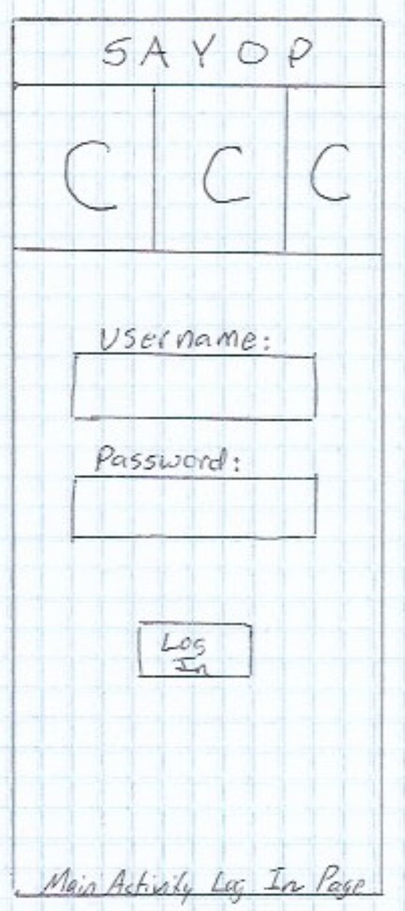 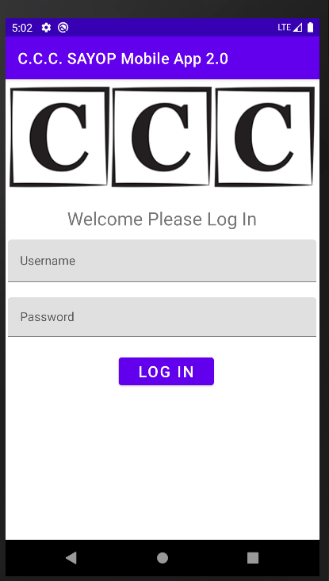

Figure 1: Low Fidelity

Figure 2: High Fidelity

Once a user logs in, they will be taken to the Main_Activity_Home_Page. The user can then select to view Terms, Courses, Assessments, or Reports.

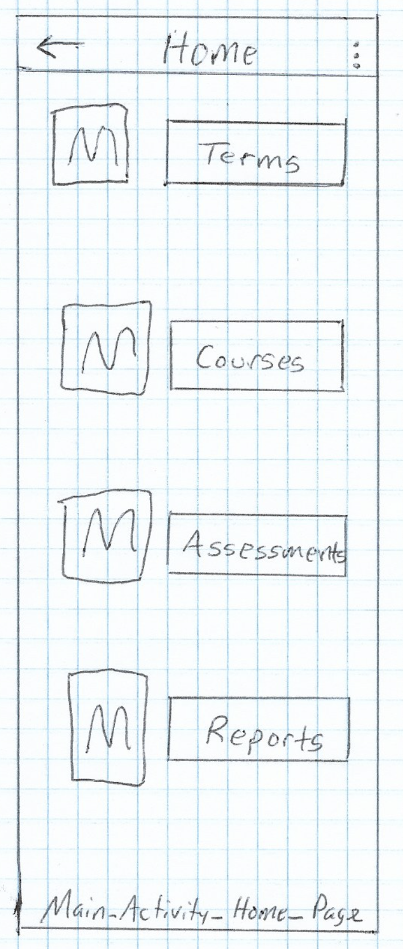 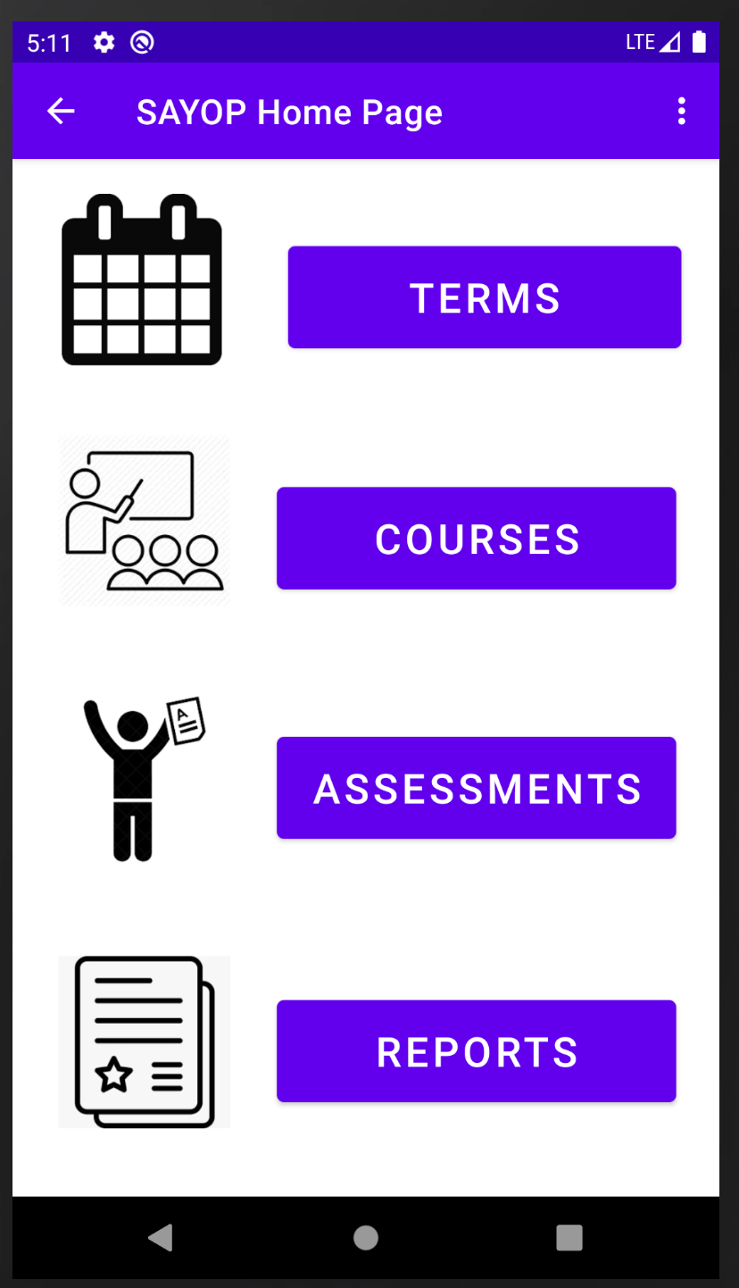

Figure 4: High Fidelity

Figure 3: Low Fidelity

Selecting the TERMS button will navigate to List_Terms. From this page the user will see all of the existing terms they are assigned to. The page will list the term name, the term start date, and the term end date. The user will be able to search the terms list, refresh the terms list, add a new term, edit a term, or return to Main_Activity_Home_Page.

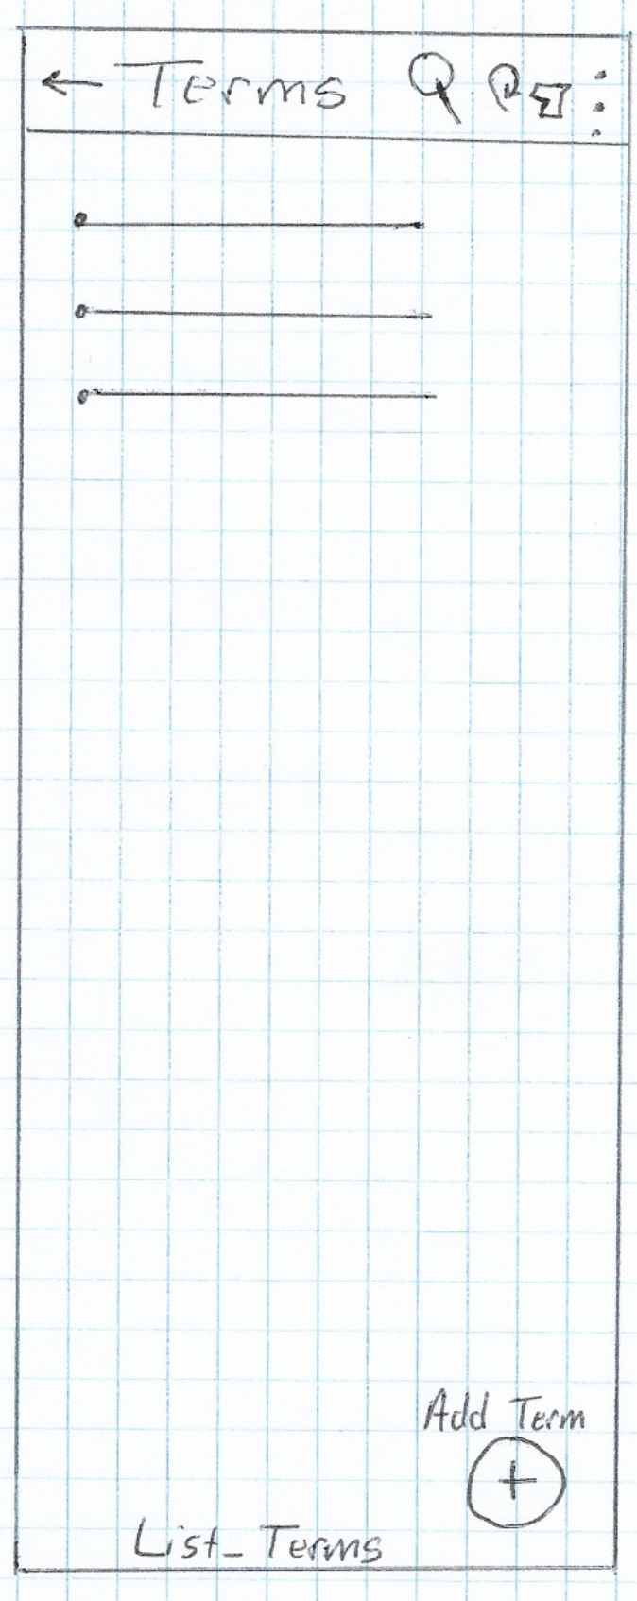 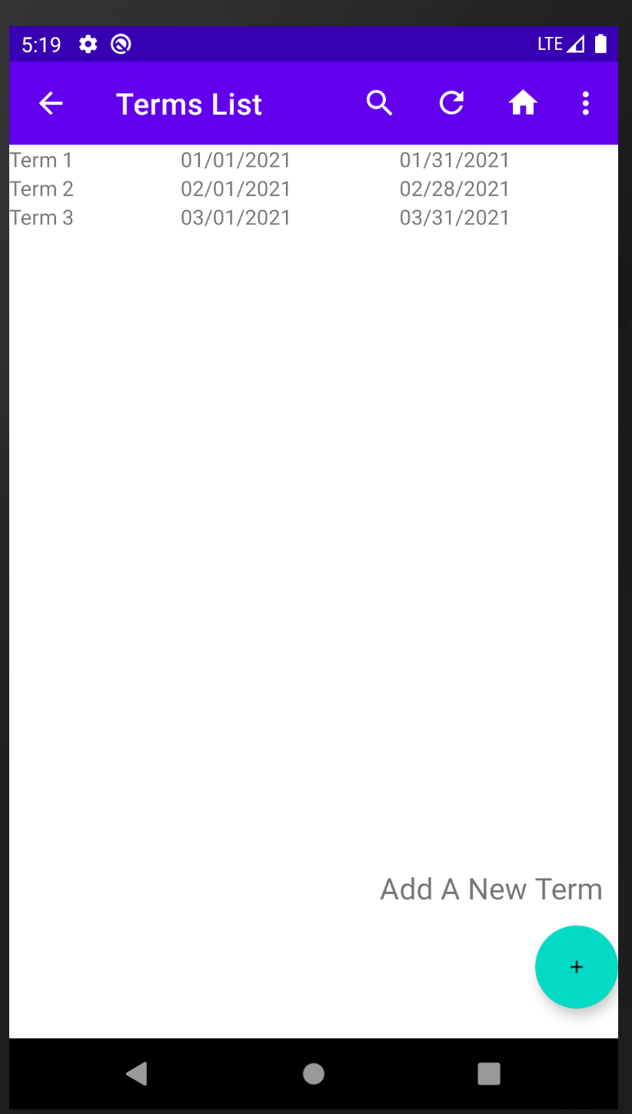

Figure 6: High Fidelity

Figure 5: Low Fidelity

Should the user decide to edit an existing term they will click on the term name in the list, and it will take them to Edit_Existing_Term. The user would be able to update the term name, start date, end date before saving. If the user wanted to add a new course or delete an associated course this would be done from the Edit_Existing_Term page. The user would also be able to send out a notification via SMS Text or Email about the Term. The user would also be able to delete the term provided no associated courses are showing. Or the user would be able to navigate back to Main_Activity_Home_Page.

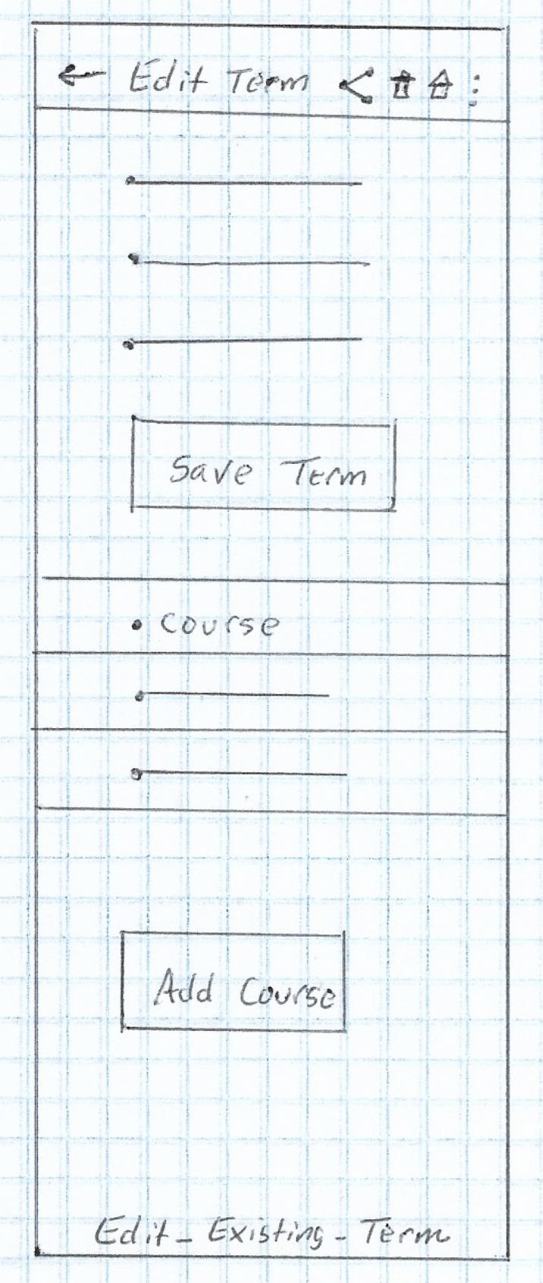 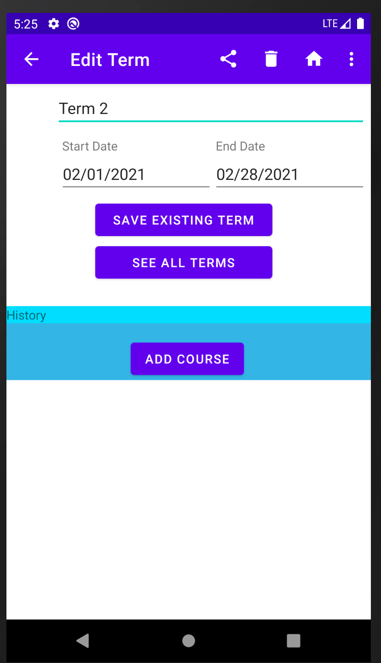

Figure 8: High Fidelity

Figure 7: Low Fidelity

If the user decided to add a new course to the existing term. They would click on the add course navigation button. The user would then be able to add a course name, start date, end date, status, instructor name, instructor phone, instructor email, and course note.

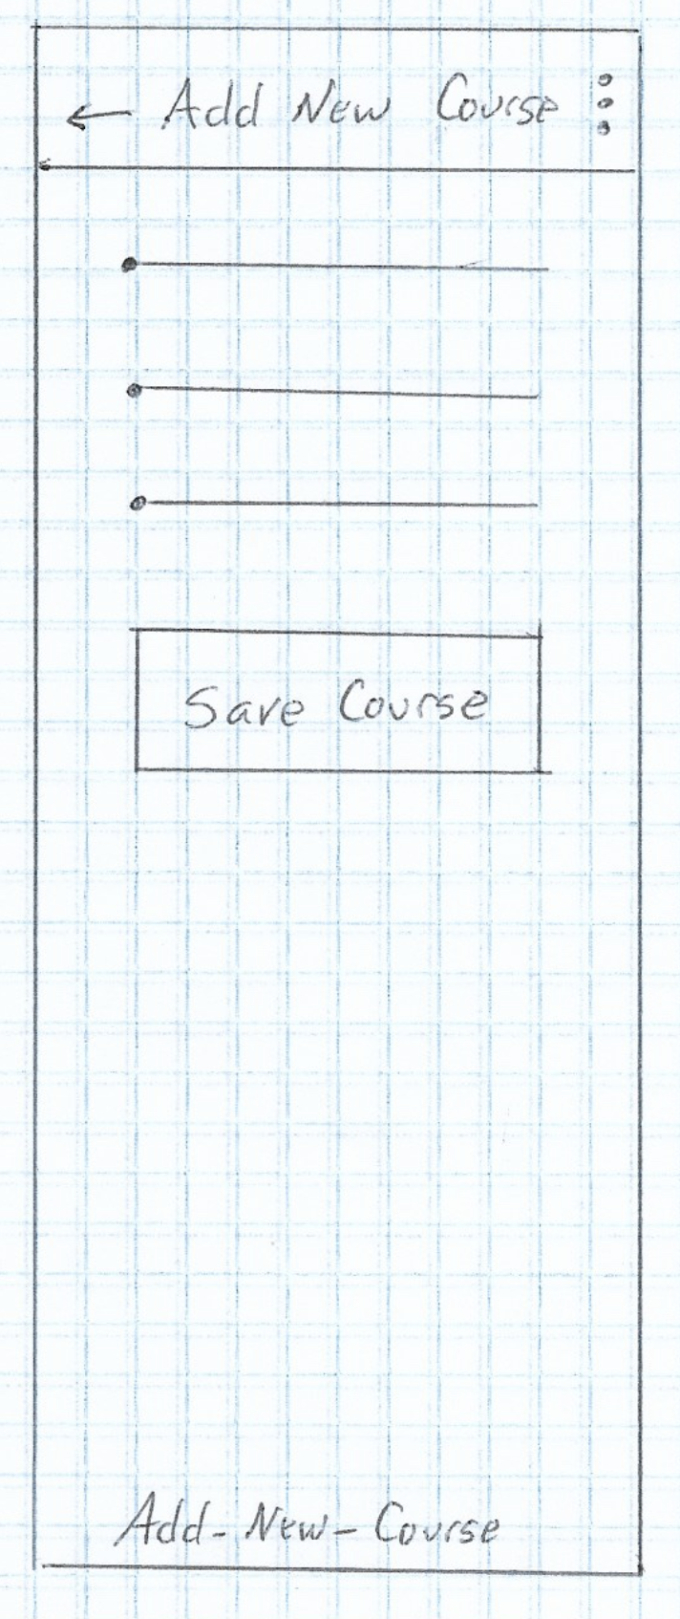 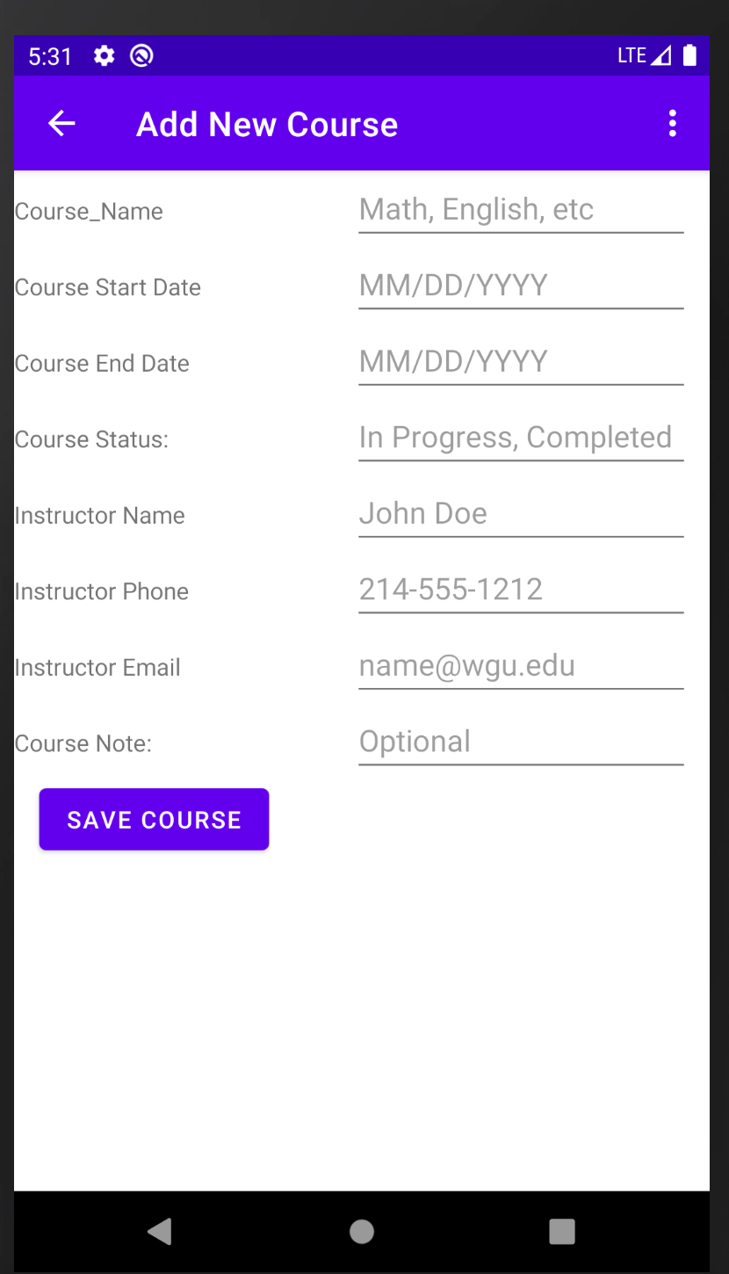

Figure 10: High Fidelity

Figure 9: Low Fidelity

From the List_Terms screen if the user decided to add a new term they would click on the floating action plus button to add a new term. This would take them to the Add_New_Term screen. The user would be able to add a term name, start, and end dates.

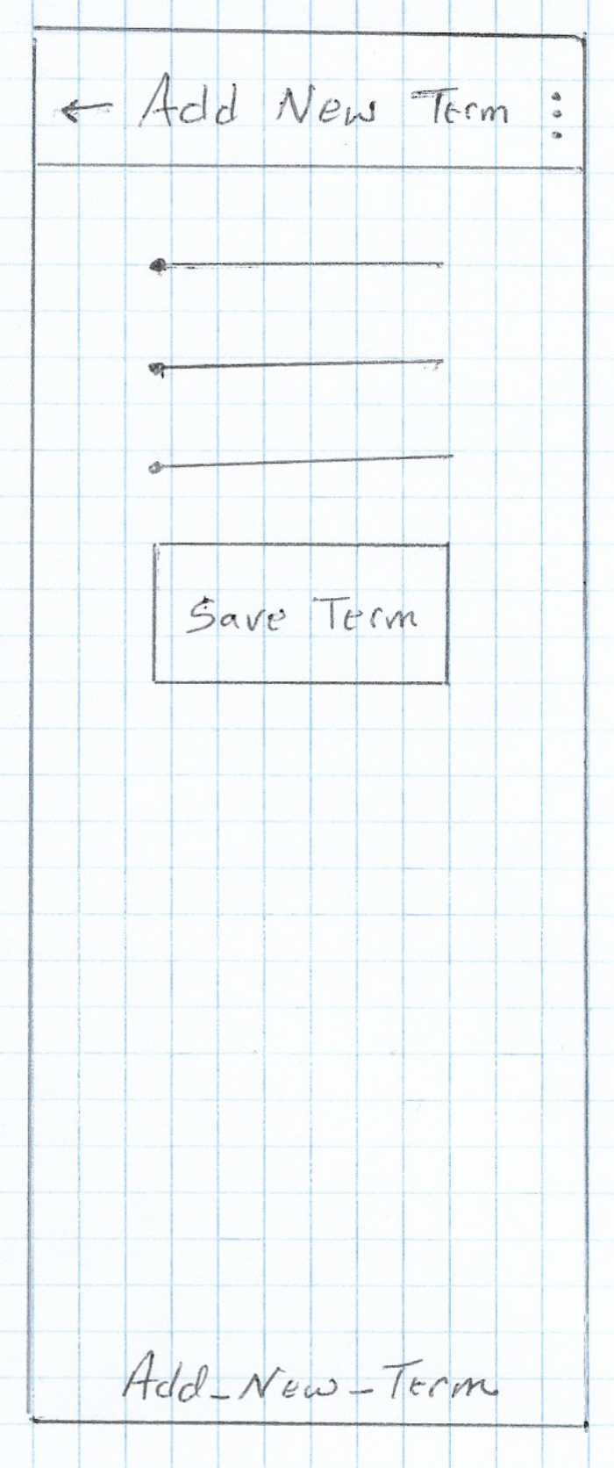 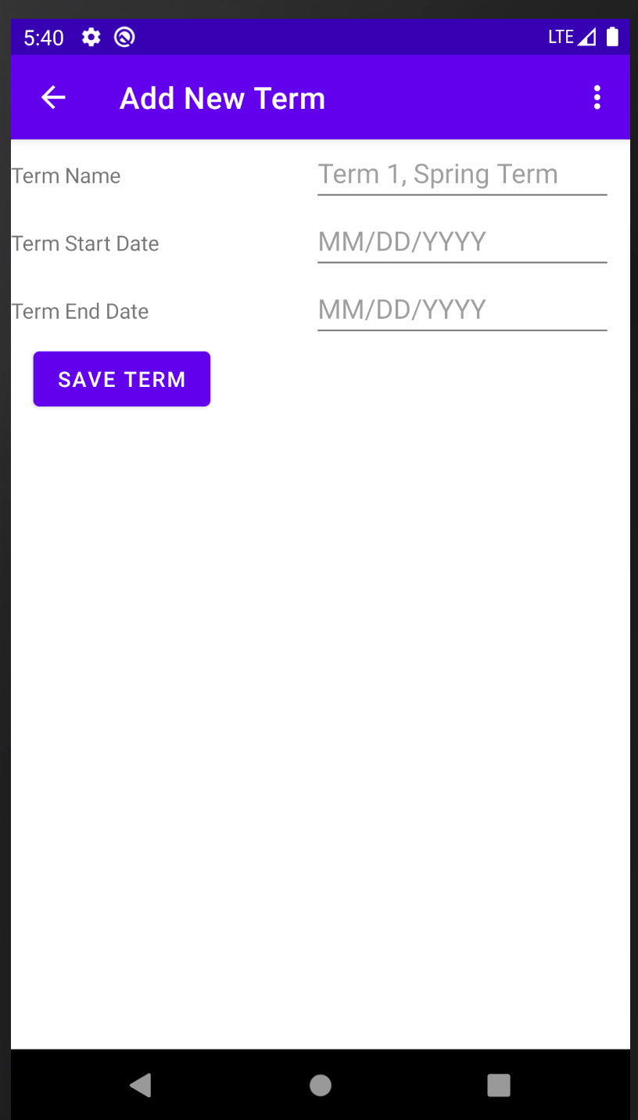

Figure 12: High Fidelity

Figure 11: Low Fidelity

From the Main_Activity_Home_Page if the user decided to view all courses, they are enrolled in they would click the Courses navigational button which would take them to List_Courses screen. From here they would be able to edit a course by clicking on the course name. From the menu they would be able to search through the course list by name. They would also be able to refresh the list or return to Activity_Main_Home_Page screen.

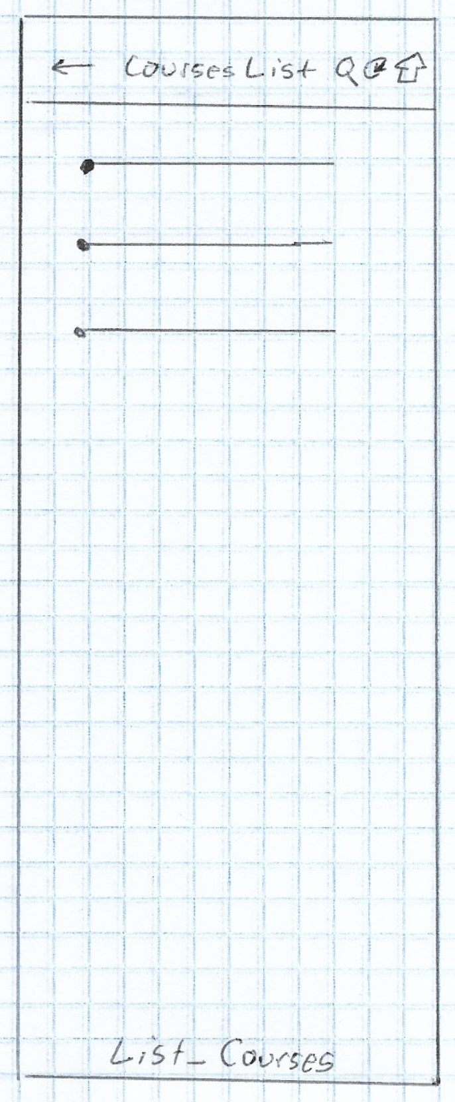 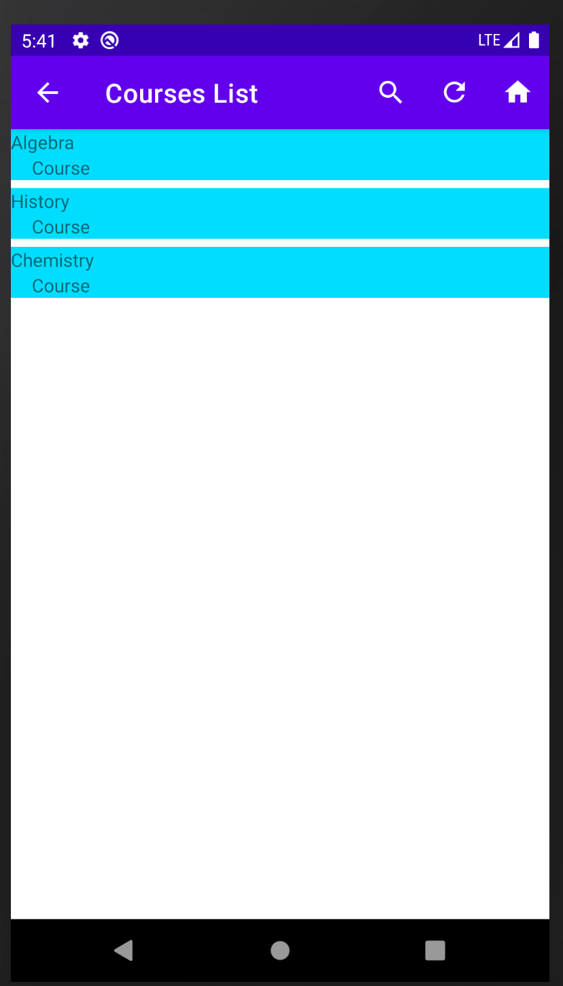

Figure 14: High Fidelity

Figure 13: Low Fidelity

From the Edit_Existing_Course page the user would be able to edit the course name, status, start date, end date, instructor name, instructor phone, instructor email, course note. The user would also be able to share the course details via SMS Text or Email. They would be able to delete the course provide no associated assessments are part of the course. The user would also be able to navigate to the home screen. They would be able to delete an associated assessment for that course in addition to adding a new assessment.

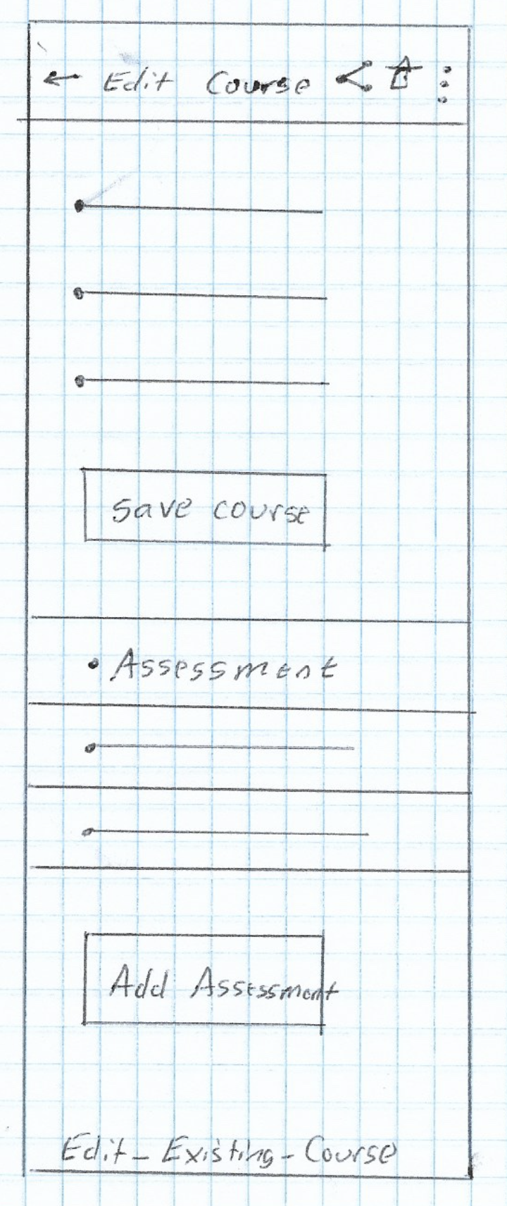 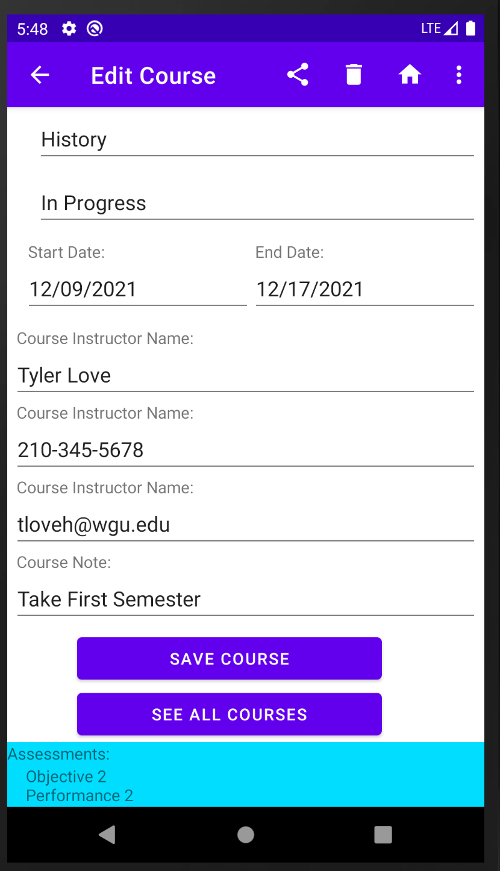

Figure 16: High Fidelity

Figure 15: Low Fidelity

From the Edit_Existing_Course if the user wanted to add a new assessment they would click the add new assessment navigational button and they would be taken to the Add_New_Assessment page. On this page the user would be able to add an assessment name, type, start date, and end date.

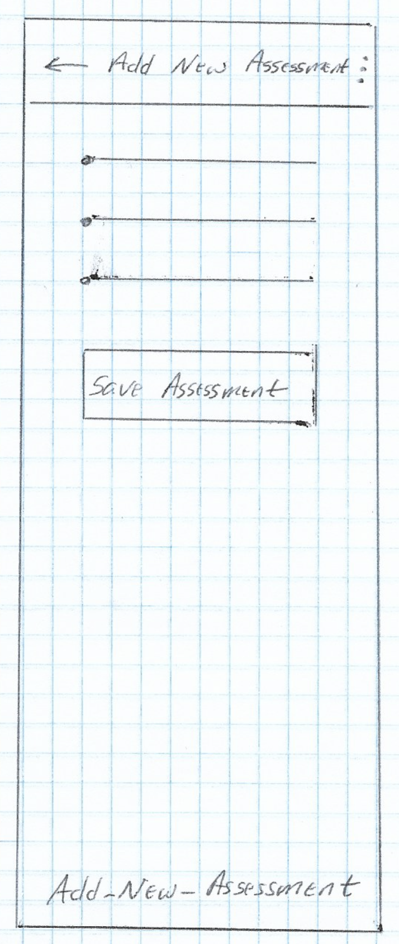 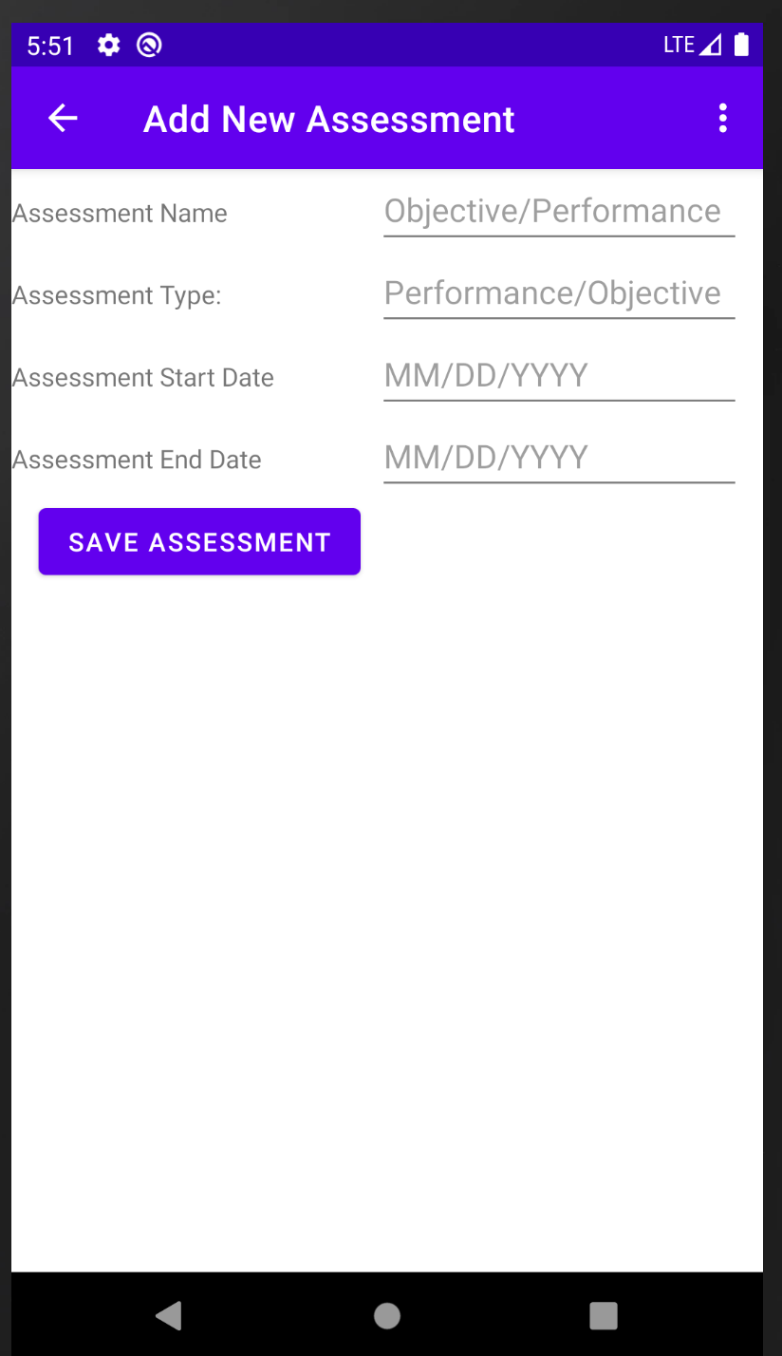

Figure 18: High Fidelity

Figure 17: Low Fidelity

From the Main_Activity_Home_Page if the user wanted to view all assessments, they are enrolled in they would click the Assessment navigational button and be taken to List_Assessments. From this screen the user would be able to edit an assessment, search through the list of assessments by name, refresh the assessments list, or return to Main_Activity_Home_Page.

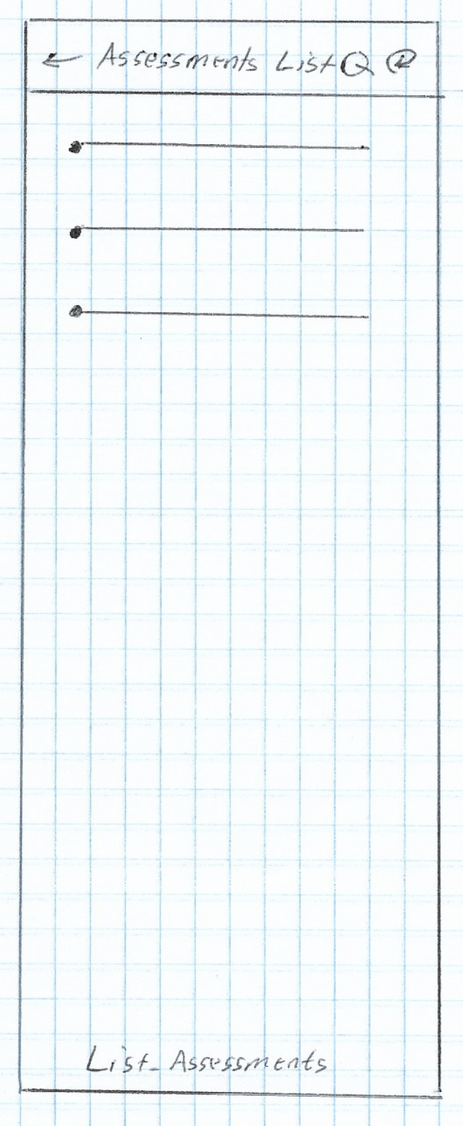 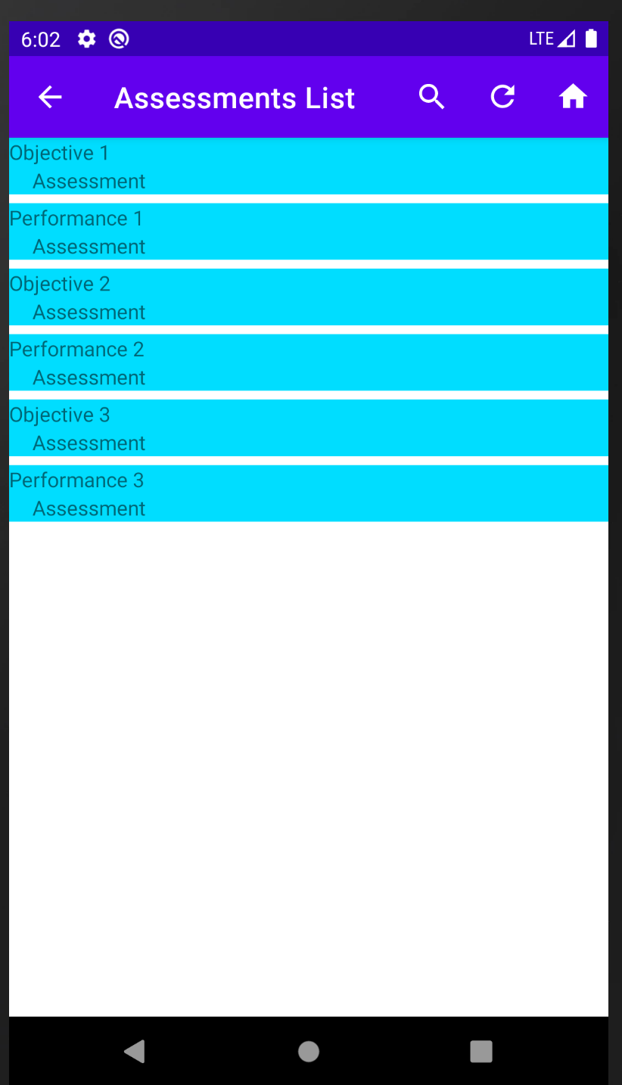

Figure 20: High Fidelity

Figure 19: Low Fidelity

If the user wanted to view edit an assessment, they would click on an assessment name from the list and be taken to Edit_Existing_Assessment. From here the user would be able to update the assessment name, type, start date, and end date. The user would also be able to share information about the assessment via SMS Text or Email. They would be able to delete the assessment or navigate to Main_Activity_Home_Page.

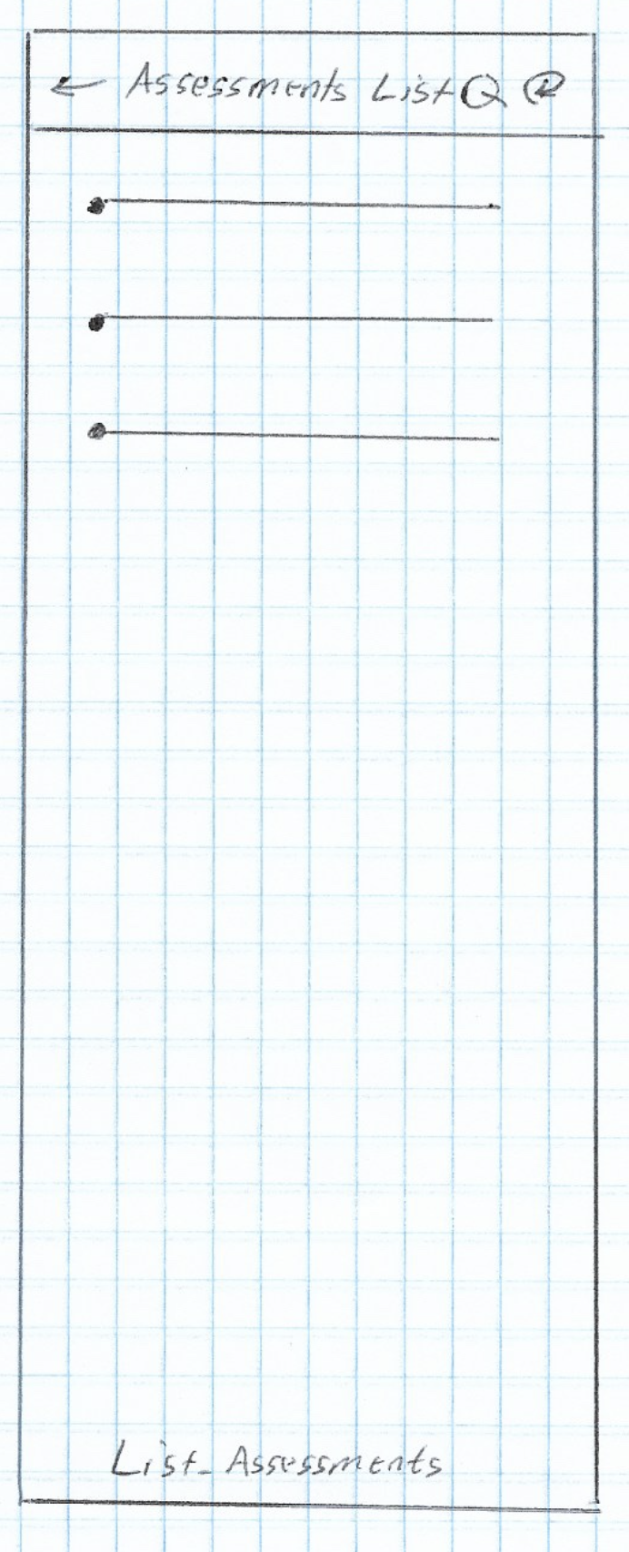 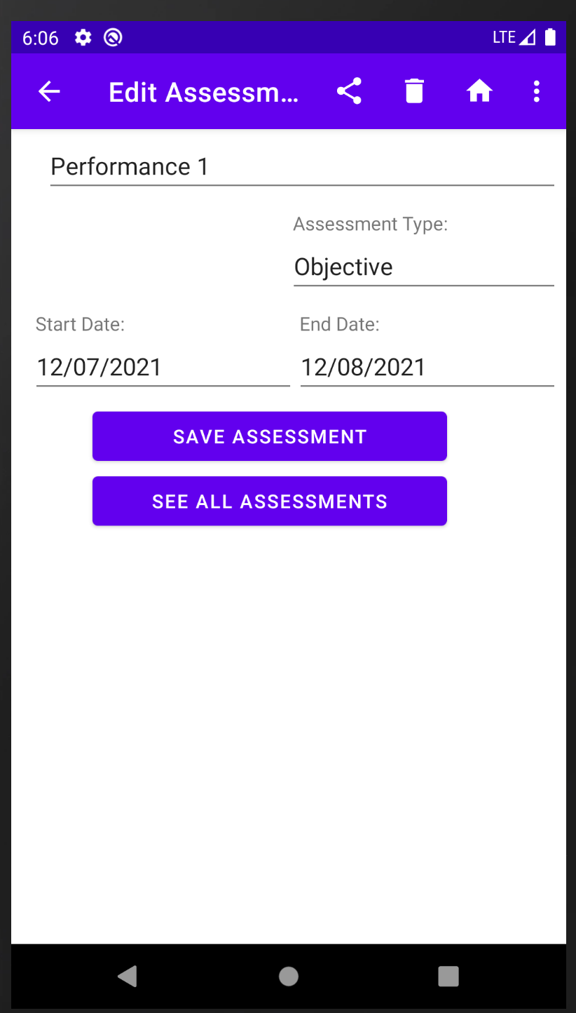

Figure 22: High Fidelity

Figure 21: Low Fidelity

From the Main_Activity_Home_Page if the user wanted to generate different types of reports, such as Terms List, Courses List, Assessments List, or Instructors List they would click on the Reports navigation button which would navigate to Reports_Page.

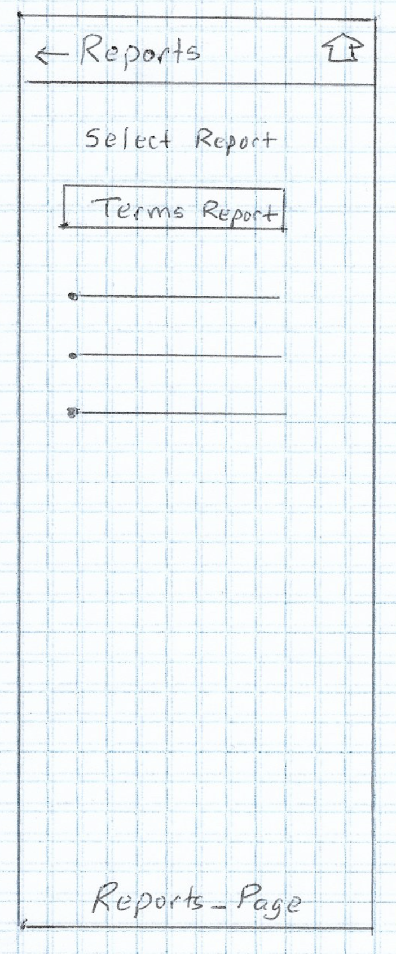 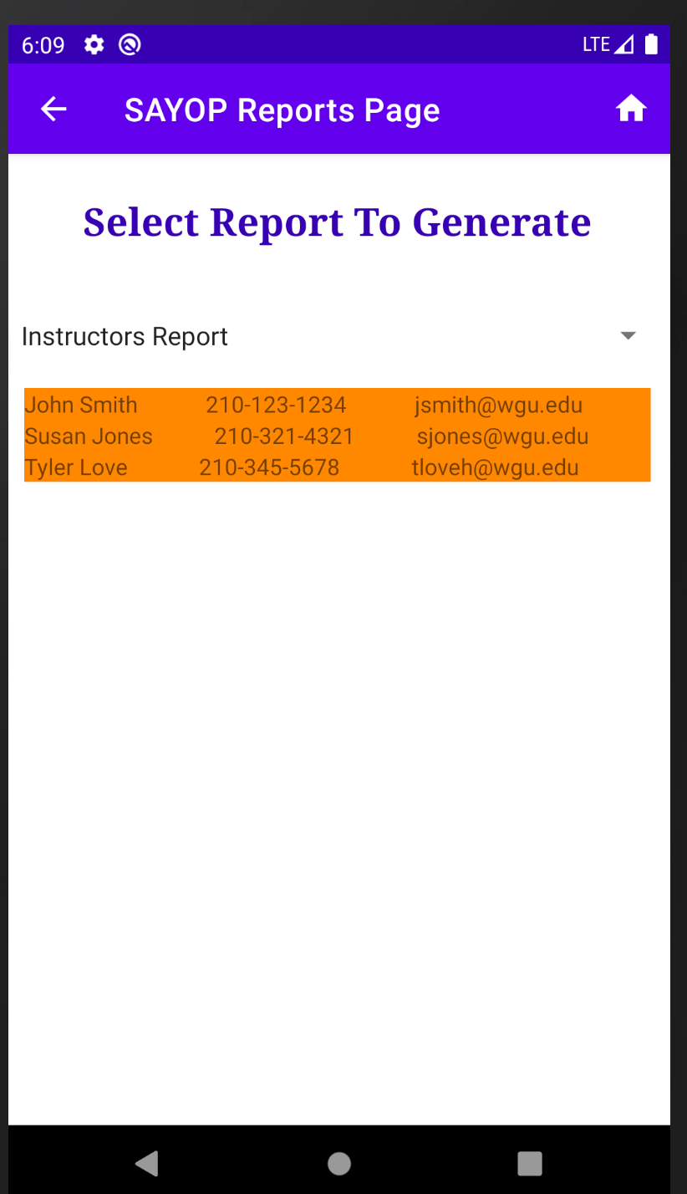

Figure 24: High Fidelity

Figure 23: Low Fidelity

# Unit Test Plan

## Introduction

### Purpose

Manual testing of the mobile app with the user interface was used to test the program for expected functionality and error handling. Each test case was written into the application as a unit test and integrated at each point in the application’s development process as each method was being introduced by the developer.

Unit tests were then incorporated into the CICD (Continual Integration, Continual Delivery) pipeline using Jenkins’s Automation tooling where a full testing of all the Unit Tests were ran every time code was committed to the developer’s branch for integration and testing by quality engineers. Two additional full unit test checks were ran. The first one ran before a development branch was released into the staging branch and once more before it was released as part of the beta release. Listed below is the comprehensive list of unit test cases written and tested through automated unit tests.

|  |  |  |  |  |  |
| --- | --- | --- | --- | --- | --- |
| Test Case Number | Description | Data | Expected Results | Actual Results | Pass / Fail |
| 1 | Login Attempt | User: student  Pass: password | Login success | Login success | Pass |
| 2. | Login Attempt | User: null  Pass: null | Login Fail, Error Message | Login Fail, Error Message | Pass |
| 3 | Login Attempt | User: null  Pass: password | Login Fail, Error Message | Login Fail, Error Message | Pass |
| 4 | Login Attempt | User student  Pass: null | Login Fail, Error Message | Login Fail, Error Message | Pass |
| 5 | Login Attempt | User: something Pass: 1234 | Login Fail, Error Message | Login Fail, Error Message | Pass |
| 6 | Logout Attempt | Select logout | Logout | Return to Login Screen | Pass |
| 7 | See Terms | seeAllTerms() | Get a list of all terms | Returned result of term names, start and end dates | Pass |
| 8 | See Courses | seeAllCourses() | Get a list of all courses | Returned result with course names | Pass |
| 9 | See Assessments | seeAllAssessments() | Get a list of all assessments | Returned result with assessment names | Pass |
| 10 | See Reports | Generate Terms Report | Get a list of all Terms | Terms Report Generated | Pass |
| 11 | See Reports | Generate Courses Report | Get a list of all Courses | Courses Report Generated | Pass |
| 12 | See Reports | Generate Assessments Report | Get a list of all Assessments | Assessments Report Generated | Pass |
| 13 | See Reports | Generate Instructors Report | Get a list of all Instructors | Instructor’s Report Generated | Pass |
| 14 | Add New Term | Term Name: test Start Date: 01/01/21 End Date: 01/02/21 | Create new term | New Term Created | Pass |
| 15 | Add New Term | Term Name: test Start Date: 01/02/21 End Date: 01/01/21 | Error Message | End date cannot be before start | Pass |
| 16 | Add New Term | Term Name: test Start Date: 01/01/21 End Date: 02/15/21 | Error Message | Term cannot be longer than 30 days | Pass |
| 17 | Add New Term | Term Name: test Start Date: 01/01/21 End Date: 01/01/21 | Error Message | Term start and end date cannot be the same | Pass |
| 18 | Add New Term | Term Name: null Start Date: 01/01/21 End Date: 01/01/21 | Error Message | Term name cannot be empty | Pass |
| 19 | Add New Term | Term Name: test Start Date: null End Date: 01/01/21 | Error Message | Term start date cannot be empty | Pass |
| 20 | Add New Term | Term Name: test Start Date: 01/01/21 End Date: null | Error Message | Term end date cannot be empty | Pass |
| 21 | Edit Term | Term Name: test Start Date: 01/01/21 End Date: 01/01/21 | Save Term | Save Term | Pass |
| 22 | Edit Term | Term Name: test Start Date: 01/02/21 End Date: 01/01/21 | Error Message | End date cannot be before start | Pass |
| 23 | Edit Term | Term Name: test Start Date: 01/01/21 End Date: 02/15/21 | Error Message | Term cannot be longer than 30 days | Pass |
| 24 | Edit Term | Term Name: test Start Date: 01/01/21 End Date: 01/01/21 | Error Message | Term start and end date cannot be the same | Pass |
| 25 | Edit Term | Term Name: null Start Date: 01/01/21 End Date: 01/01/21 | Error Message | Term name cannot be empty | Pass |
| 26 | Edit Term | Term Name: test Start Date: null End Date: 01/01/21 | Error Message | Term start date cannot be empty | Pass |
| 27 | Edit Term | Term Name: test Start Date: 01/01/21 End Date: null | Error Message | Term end date cannot be empty | Pass |
| 28 | Edit Term | Delete Term | Success | Success | Pass |
| 29 | Edit Term | Delete Term | Error Message | Cannot delete a term with associated courses | Pass |
| 30 | Edit Term | Remove Course from Term | Success | Success | Pass |
| 30 | Add New Course | Course Name: test  Start Date: 01/01/21  End Date: 01/31/21  Status: test  Instructor Name: test  Instructor Phone: 111-111-1111  Instructor Email: test@domain.com  Note: test | Success | Success | Pass |
| 31 | Add New Course | Course Name: test  Start Date: 01/02/21  End Date: 01/01/21  Status: test  Instructor Name: test  Instructor Phone: 111-111-1111  Instructor Email: test@domain.com  Note: test | Error Message | End date cannot come before start date | Pass |
| 32 | Add New Course | Course Name: test  Start Date: 01/01/21  End Date: 01/01/21  Status: test  Instructor Name: test  Instructor Phone: 111-111-1111  Instructor Email: test@domain.com  Note: test | Error Message | Start date and end date cannot be the same | Pass |
| 33 | Add New Course | Course Name: test  Start Date: 01/01/21  End Date: 02/15/21  Status: test  Instructor Name: test  Instructor Phone: 111-111-1111  Instructor Email: test@domain.com  Note: test | Error Message | Start date and end date cannot be greater than 30 days | Pass |
| 34 | Add New Course | Course Name: null  Start Date: 01/01/21  End Date: 01/31/21  Status: test  Instructor Name: test  Instructor Phone: 111-111-1111  Instructor Email: test@domain.com  Note: test | Error Message | Course name cannot be empty | Pass |
| 35 | Add New Course | Course Name: null  Start Date: Pass  End Date: 01/31/21  Status: test  Instructor Name: test  Instructor Phone: 111-111-1111  Instructor Email: test@domain.com  Note: test | Error Message | Course start date cannot be empty | Pass |
| 36 | Add New Course | Course Name: test  Start Date: 01/01/21  End Date: null  Status: test  Instructor Name: test  Instructor Phone: 111-111-1111  Instructor Email: test@domain.com  Note: test | Error Message | Course end date cannot be empty | Pass |
| 37 | Add New Course | Course Name: test  Start Date: 01/01/21  End Date: 01/31/21  Status: null  Instructor Name: test  Instructor Phone: 111-111-1111  Instructor Email: test@domain.com  Note: test | Error Message | Course status cannot be empty | Pass |
| 38 | Add New Course | Course Name: test  Start Date: 01/01/21  End Date: 01/31/21  Status: test  Instructor Name: null  Instructor Phone: 111-111-1111  Instructor Email: test@domain.com  Note: test | Error Message | Course instructor name cannot be empty | Pass |
| 39 | Add New Course | Course Name: test  Start Date: 01/01/21  End Date: 01/31/21  Status: test  Instructor Name: test  Instructor Phone: null  Instructor Email: test@domain.com  Note: test | Error Message | Course instructor phone cannot be empty | Pass |
| 40 | Add New Course | Course Name: test  Start Date: 01/01/21  End Date: 01/31/21  Status: test  Instructor Name: null  Instructor Phone: 111-111-1111  Instructor Email: null  Note: test | Error Message | Course instructor email cannot be empty | Pass |
| 41 | Edit Course | Course Name: test  Start Date: 01/01/21  End Date: 01/31/21  Status: test  Instructor Name: test  Instructor Phone: 111-111-1111  Instructor Email: test@domain.com  Note: test | Save Course | Success | Pass |
| 42 | Edit Course | Course Name: test  Start Date: 01/02/21  End Date: 01/01/21  Status: test  Instructor Name: test  Instructor Phone: 111-111-1111  Instructor Email: test@domain.com  Note: test | Error Message | End date cannot come before start date | Pass |
| 43 | Edit Course | Course Name: test  Start Date: 01/01/21  End Date: 02/15/21  Status: test  Instructor Name: test  Instructor Phone: 111-111-1111  Instructor Email: test@domain.com  Note: test | Error Message | Course cannot be greater than 30 days | Pass |
| 44 | Edit Course | Course Name: test  Start Date: 01/01/21  End Date: 01/01/21  Status: test  Instructor Name: test  Instructor Phone: 111-111-1111  Instructor Email: test@domain.com  Note: test | Error Message | Start date and end date cannot be the same | Pass |
| 45 | Edit Course | Course Name: null  Start Date: 01/01/21  End Date: 01/31/21  Status: test  Instructor Name: test  Instructor Phone: 111-111-1111  Instructor Email: test@domain.com  Note: test | Error Message | Course name cannot be empty | Pass |
| 46 | Edit Course | Course Name: test  Start Date: null  End Date: 01/31/21  Status: test  Instructor Name: test  Instructor Phone: 111-111-1111  Instructor Email: test@domain.com  Note: test | Error Message | Course start date cannot be empty | Pass |
| 47 | Edit Course | Course Name: test  Start Date: 01/01/21  End Date: null  Status: test  Instructor Name: test  Instructor Phone: 111-111-1111  Instructor Email: test@domain.com  Note: test | Error Message | Course end date cannot be empty | Pass |
| 48 | Edit Course | Course Name: test  Start Date: 01/01/21  End Date: 01/31/21  Status: null  Instructor Name: test  Instructor Phone: 111-111-1111  Instructor Email: test@domain.com  Note: test | Error Message | Course status cannot be empty | Pass |
| 49 | Edit Course | Course Name: test  Start Date: 01/01/21  End Date: 01/31/21  Status: test  Instructor Name: null  Instructor Phone: 111-111-1111  Instructor Email: test@domain.com  Note: test | Error Message | Course instructor name cannot be empty | Pass |
| 50 | Edit Course | Course Name: test  Start Date: 01/01/21  End Date: 01/31/21  Status: test  Instructor Name: null  Instructor Phone: null  Instructor Email: test@domain.com  Note: test | Error Message | Course instructor phone cannot be empty | Pass |
| 51 | Edit Course | Course Name: test  Start Date: 01/01/21  End Date: 01/31/21  Status: test  Instructor Name: test  Instructor Phone: 111-111-1111  Instructor Email: null  Note: test | Error Message | Course instructor cannot be empty | Pass |
| 52 | Edit Course | Delete Course | Success | Course Deleted | Pass |
| 53 | Edit Course | Delete Course | Error Message | Course cannot be deleted with associated assessments | Pass |
| 54 | Edit Course | Remove Assessment from Course | Success | Success | Pass |
| 55 | Add New Assessment | Assessment Name: test Type: test Start Date: 01/01/2022 End Date: 01/31/2022 | Success | Success | Pass |
| 56 | Add New Assessment | Assessment Name: test Type: test Start Date: 02/01/2022 End Date: 01/31/2022 | Error Message | Assessment End date cannot be before Start date | Pass |
| 57 | Add New Assessment | Assessment Name: test Type: test Start Date: 01/01/2022 End Date: 02/15/2022 | Error Message | Assessment cannot be more than 30 days. | Pass |
| 58 | Add New Assessment | Assessment Name: test Type: test Start Date: 01/01/2022 End Date: 01/01/2022 | Error Message | Assessment Start date and End date cannot be the same date. | Pass |
| 59 | Add New Assessment | Assessment Name: null Type: test Start Date: 01/01/2022 End Date: 01/31/2022 | Error Message | Assessment name cannot be empty | Pass |
| 60 | Add New Assessment | Assessment Name: test Type: null Start Date: 01/01/2022 End Date: 01/31/2022 | Error Message | Assessment type cannot be empty | Pass |
| 61 | Add New Assessment | Assessment Name: test Type: test Start Date: null End Date: 01/31/2022 | Error Message | Assessment Start date cannot be empty | Pass |
| 62 | Add New Assessment | Assessment Name: test Type: test Start Date: 01/01/2022 End Date: null | Error Message | Assessment End date cannot be empty | Pass |
| 63 | Edit Assessment | Assessment Name: test Type: test Start Date: 01/01/2022 End Date: 01/31/2022 | Success | Success | Pass |
| 64 | Edit Assessment | Assessment Name: test Type: test Start Date: 01/01/2022 End Date: 02/01/2022 | Error Message | Assessment End date cannot be before Start date | Pass |
| 65 | Edit Assessment | Assessment Name: test Type: test Start Date: 01/01/2022 End Date: 02/15/2022 | Error Message | Assessment cannot be more than 30 days | Pass |
| 66 | Edit Assessment | Assessment Name: test Type: test Start Date: 01/01/2022 End Date: 01/01/2022 | Error Message | Assessment Start date and End date cannot be the same | Pass |
| 67 | Edit Assessment | Assessment Name: null Type: test Start Date: 01/01/2022 End Date: 01/31/2022 | Error Message | Assessment name cannot be empty | Pass |
| 68 | Edit Assessment | Assessment Name: test Type: null Start Date: 01/01/2022 End Date: 01/31/2022 | Error Message | Assessment type cannot be empty | Pass |
| 69 | Edit Assessment | Assessment Name: test Type: test Start Date: null End Date: 01/31/2022 | Error Message | Assessment Start date cannot be empty | Pass |
| 70 | Edit Assessment | Assessment Name: test Type: test Start Date: 01/01/2022 End Date: null | Error Message | Assessment End date cannot be empty | Pass |

### Overview

As the development has been writing each unit test during the coding phase, they have continually done regression test as each new feature has been added to the mobile application. Any new bugs were documented with an expected result and actual result inside a new JIRA ticket. Based on severity and priority, that bug was either repaired in the development branch it was discovered in, or it was dealt with in a new branch. If the bug was placed in a new branch, the existing issue was placed on hold with a “depends by” link as so the original issue and bug were released at the same time into the staging environment.

## Test Plan

### Items

An emulator and/or a physical android device will be needed to run each test.

### Features

* Add a new term
* Edit a term
* Delete a term
* Add a new course to a term
* Delete a course to a term
* Edit a course
* Delete a course
* Add a new assessment to a course
* Edit an assessment
* Delete an assessment
* Run a terms list report
* Run a course list report
* Run an assessment list report
* Run an instructor list report

### Deliverables

Please view the 70-unit tests in the table marked under section test cases and results.

### Tasks

* Follow each test case
* Document actual results and expected results
* Any new bugs introduced were documented and sent back to the developer for rework or to be handled in a separate issue.
* Complete the test case and mark the issue as pass or fail

### Needs

The following is needed for each test case to be properly tested:

* JIRA Project Management Software
* GitHub repository
* Confluence Documentation Software
* Android Studio or IntelliJ Integrated Development Environment Software
* Laptop or Desktop
* Emulator or Physical Android Testing Device

### Pass/Fail Criteria

A pass would be placed on an individual issue if the quality engineer performed their test and the result of the test matched that which is documented by the developer in the testing instructions. If the expected result is not reached, the quality engineer reattempts the testing steps another time, carefully following all steps to verify nothing was missed in the first attempt. If the results from the second attempt do not match the expected results, the quality engineer will reach out to the developer through email or instant messenger.

The developer will then work with the quality engineer one on one to verify that all the test environment is set up correctly and that the testing instructions are clearly understood by the tester. If some confusion, misunderstanding, or interpretation was misconstrued by the quality engineer, the developer will rewrite the testing instructions more clearly. If the developer is able to verify the actual results are different from the expected results the quality engineer will mark the issue as fail, and send it back to the developer for rework or correction to be made in a new issue.

## Specifications

Screen shot for add a new term:

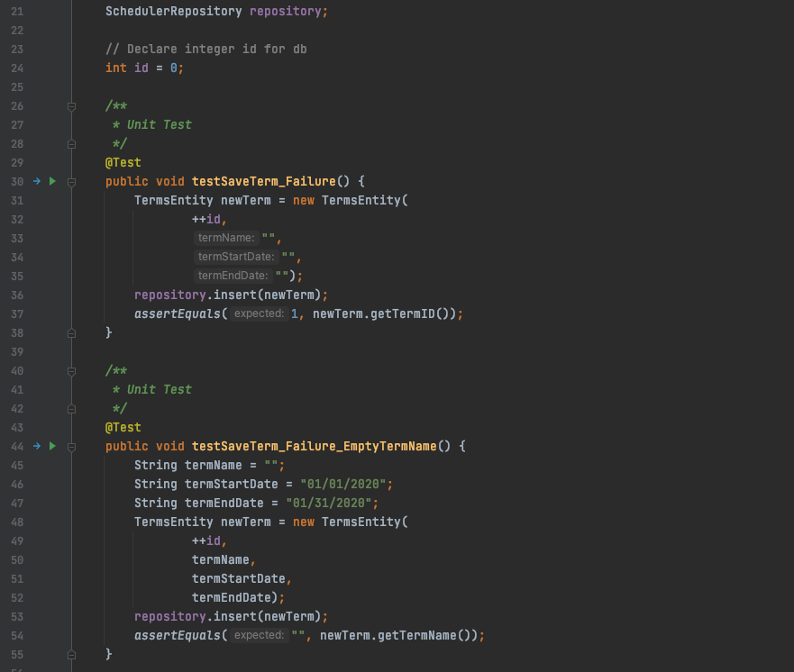

Screen shot for add a new assessment:

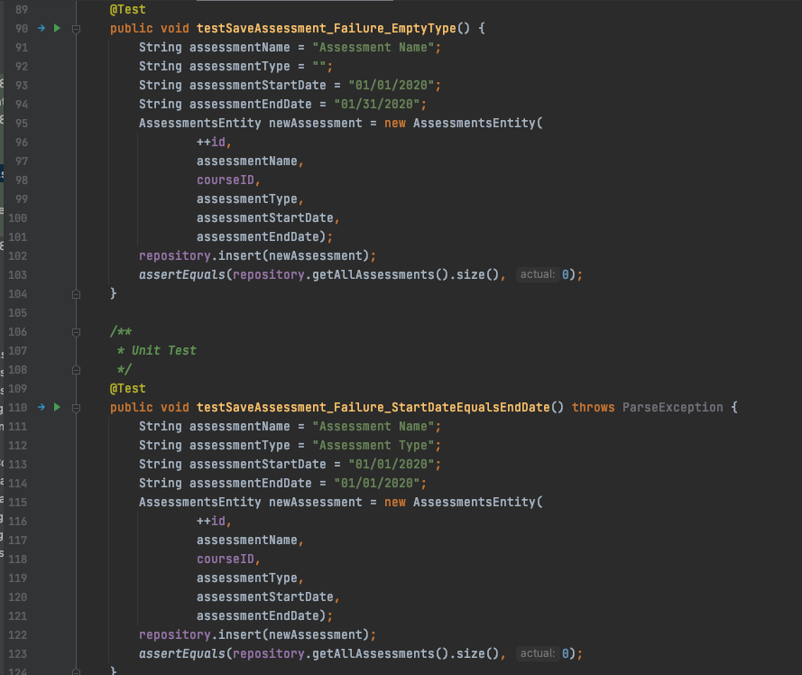

## Procedures

The unit tests run when the following takes place:

* A new development branch is created
* A development branch with new code is pushed to code review status
* A testing environment is created when an issue is ready for quality engineer
* A release branch is created when all issues are integrated together for testing
* A final check is done before all issues are released into the staging branch for beta testing

## Results

Here are the passing results for the unit test examples mentioned above:

Add a new term unit test result:

:

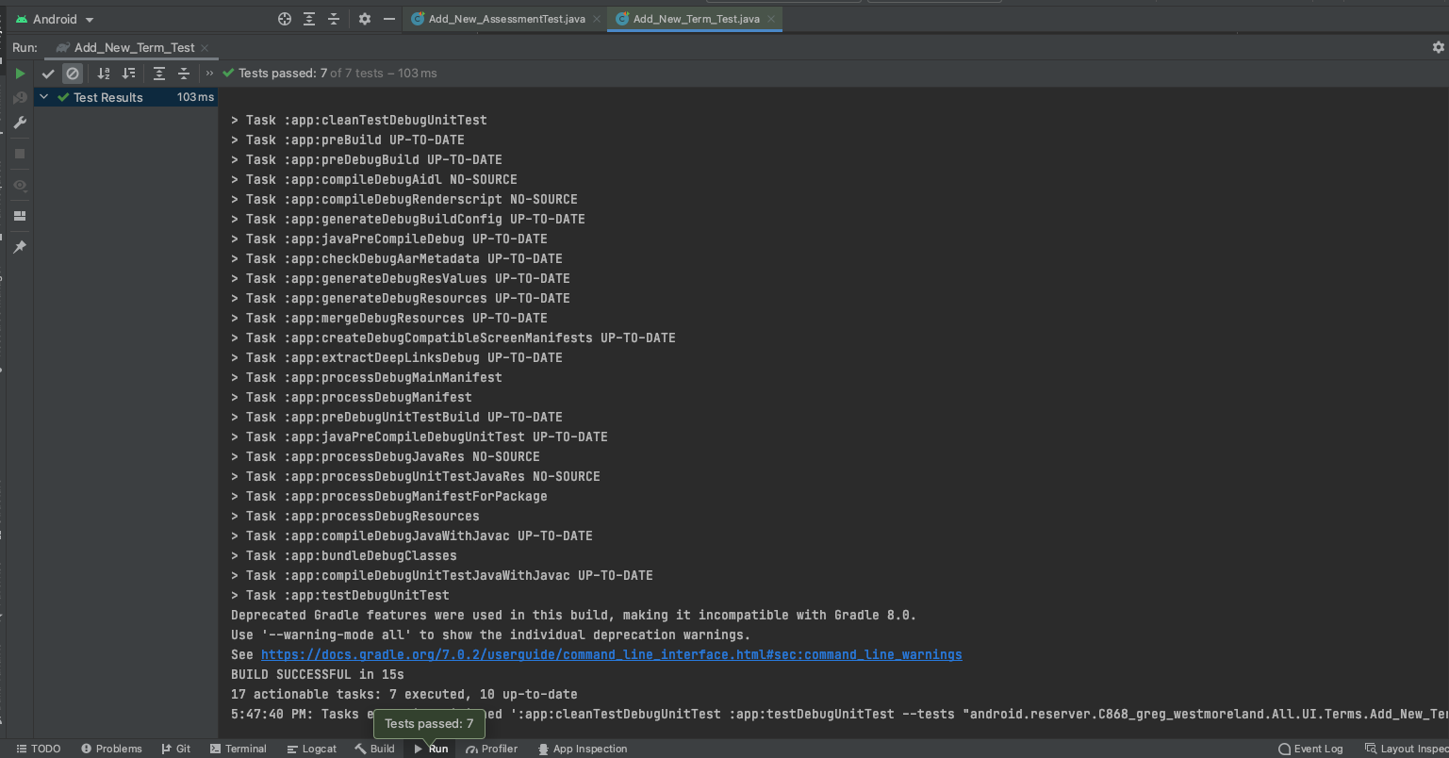

Add a new assessment unit test result:

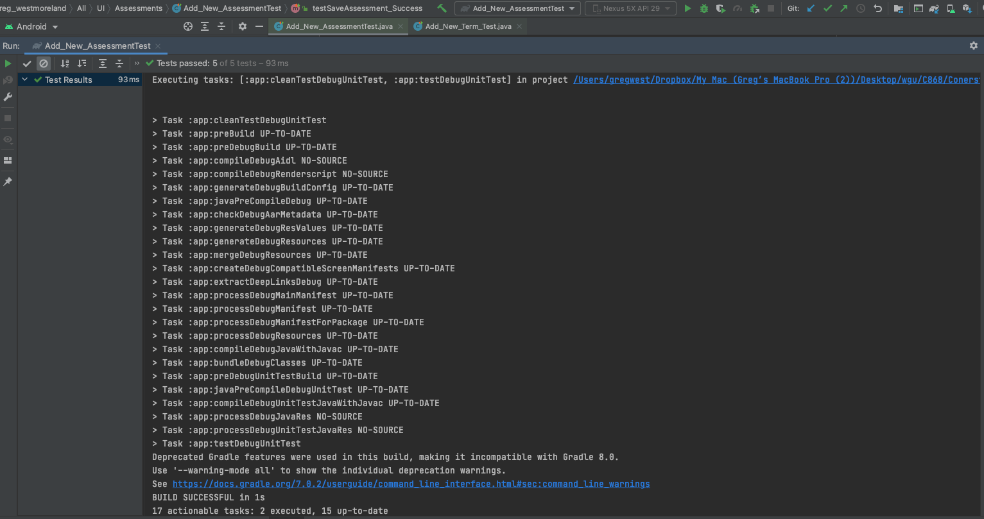

# C4. Source Code

All source code can be found in the application zip file that will be included with this submission. It will be located in the ~/src/main/java folder. Viewing and running the code on an emulator is recommended using Android Studio IDE with target Android (Version 12) SDK 31 and minimum Android (Version Oreo) SDK 26.

# C5. Link to Live Version

No live version of this currently exists.

# User Guide

## Introduction

This user guide will include instructions on how to install Android Studio for a Windows or Mac device. It will include how to open the project and instructions to launch a phone emulator to run the mobile application. Once the mobile app is running, the user’s guide will walk you through every aspect of the app including Adding/Editing/Deleting a term, course, and assessment. It will also guide you through the navigational improvements, search options, notifications, sharing, and reports.

## Installation and Using the Application

* Navigate to the following URL <https://developer.android.com/studio/?gclid=CjwKCAiA_omPBhBBEiwAcg7smbEDRvGwvqFvYpWYCNjI3w80mwgn_sAIIPwEg-HNxsAK33bW_NJ66RoCCvQQAvD_BwE&gclsrc=aw.ds#downloads>
  + Select android-studio-2020.3.1.26-windows.exe if you will be installing Android Studio on a Windows platform.
  + Select android-studio-2020.3.1.26-mac.dmg if you will be installing Android Studio on a Mac OS X platform.
* Install the Android Studio IDE onto your device.
* After Android Studio IDE is installed, you will now need to locate the .zip files included with this submission and extract them to a desired location on your device.
  + The name of the zipped filed included with this submission is called Cornerstone Community College Student Register - Android App.zip
  + Right click the file and select unzip the file with your default unzip software on your system.
    - The Unarchiver is recommended for Mac OS X - download [here](https://apps.apple.com/app/id1127253508)
    - WinZip is recommended for Windows – downloaded [here](https://www.winzip.com/en/download/winzip/)

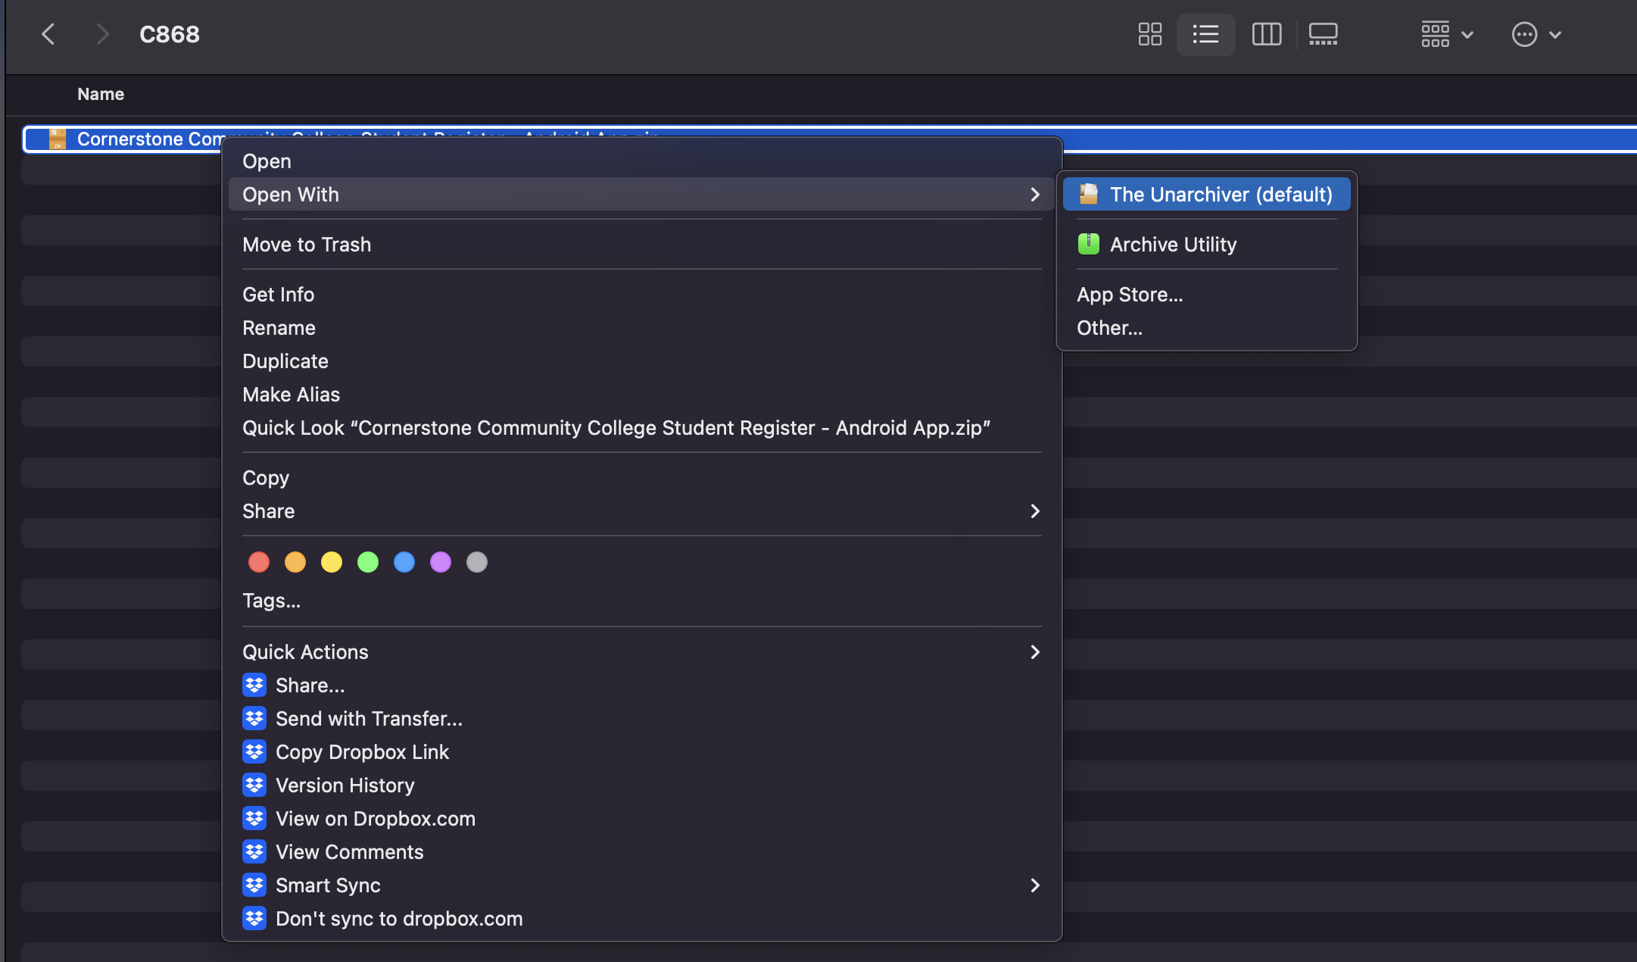

* Once unzipped it will look like this

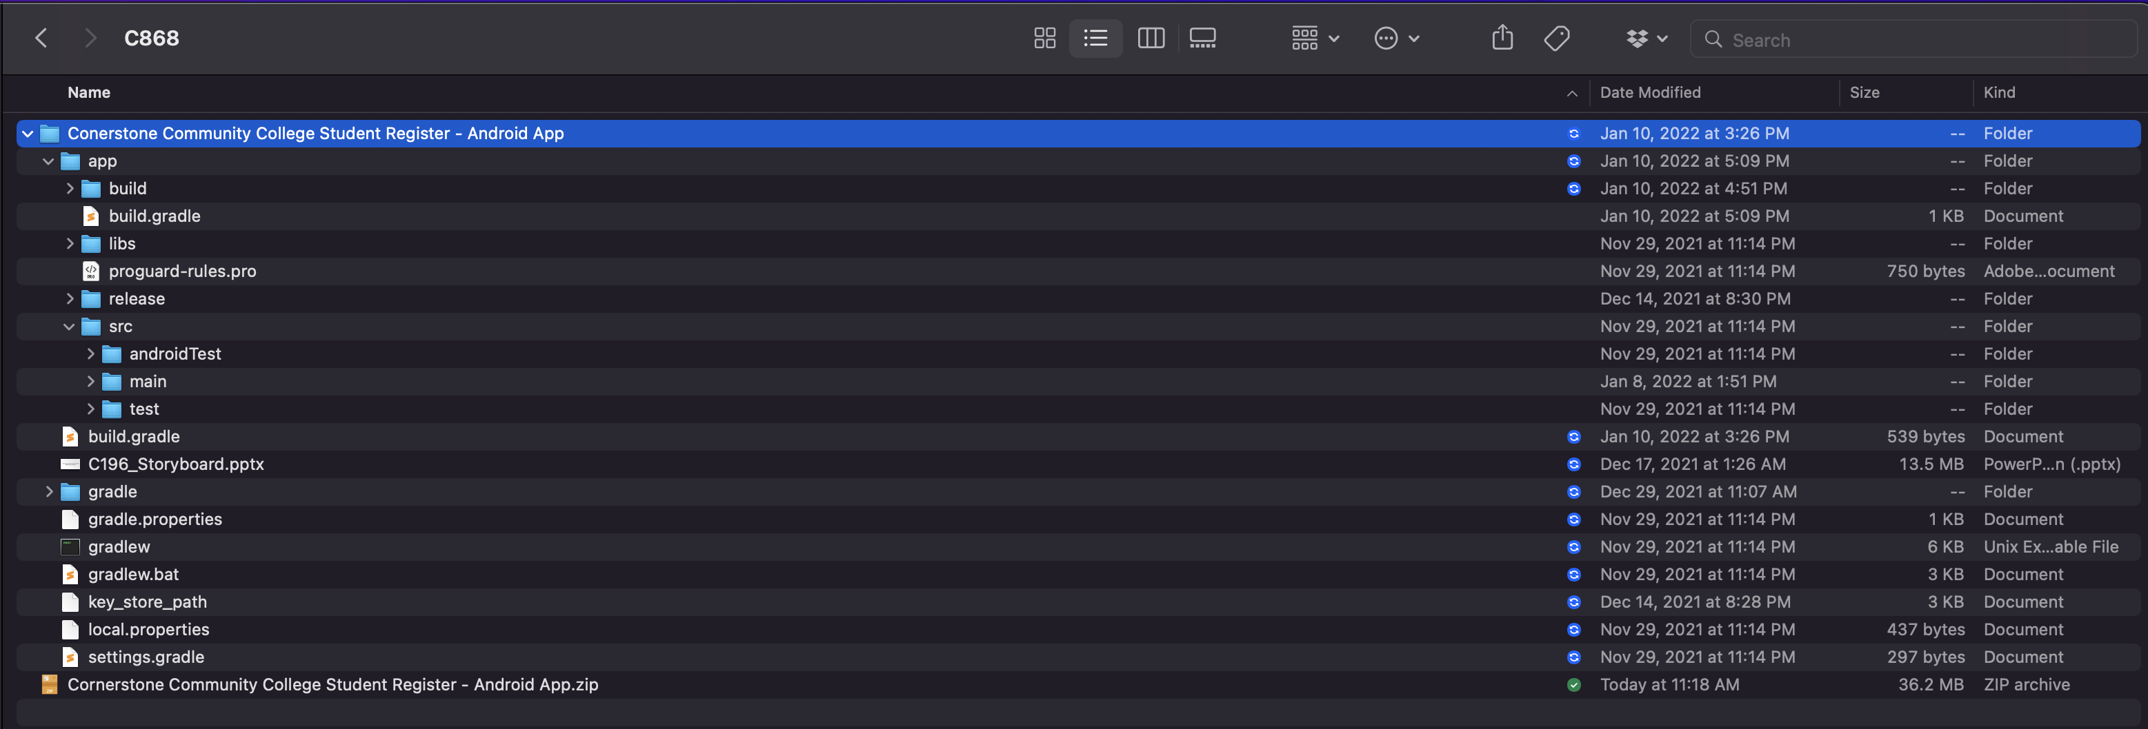

* Open Android Studio IDE



* Select Open

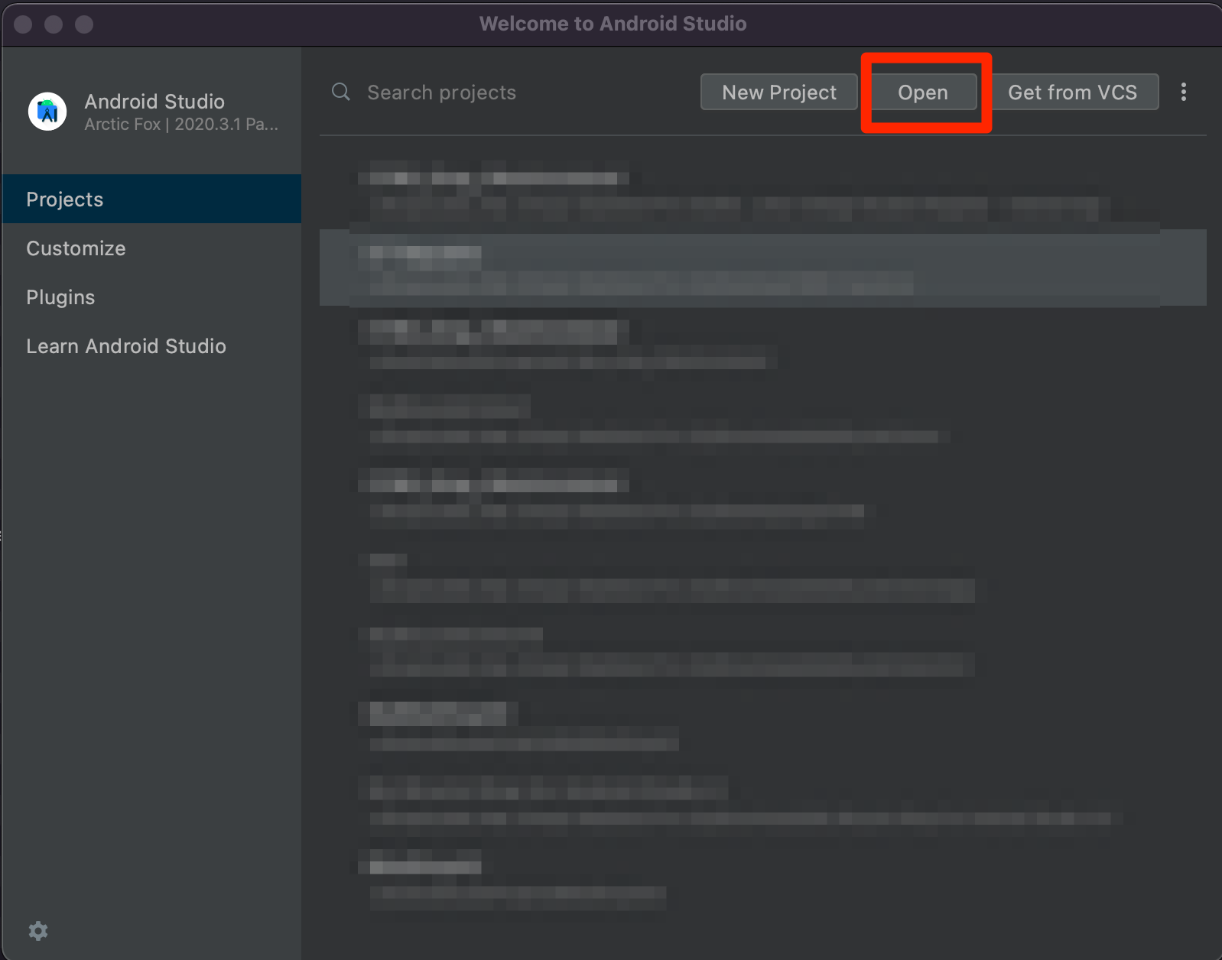

* Navigate to the location of the file where you unzipped your files, select the file, then select open

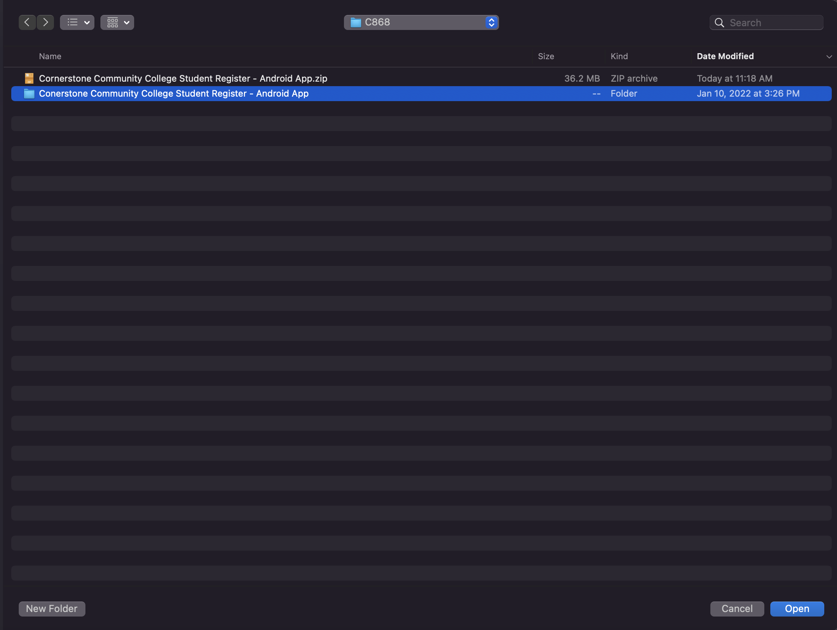

* Once opened navigate on the left pane of the IDE by expanding the java 🡪 android.reserver.C868_greg_westmoreland.All 🡪UI 🡪 Main 🡪 Main_Activity_Log_In_Page so it will be highlighted in blue

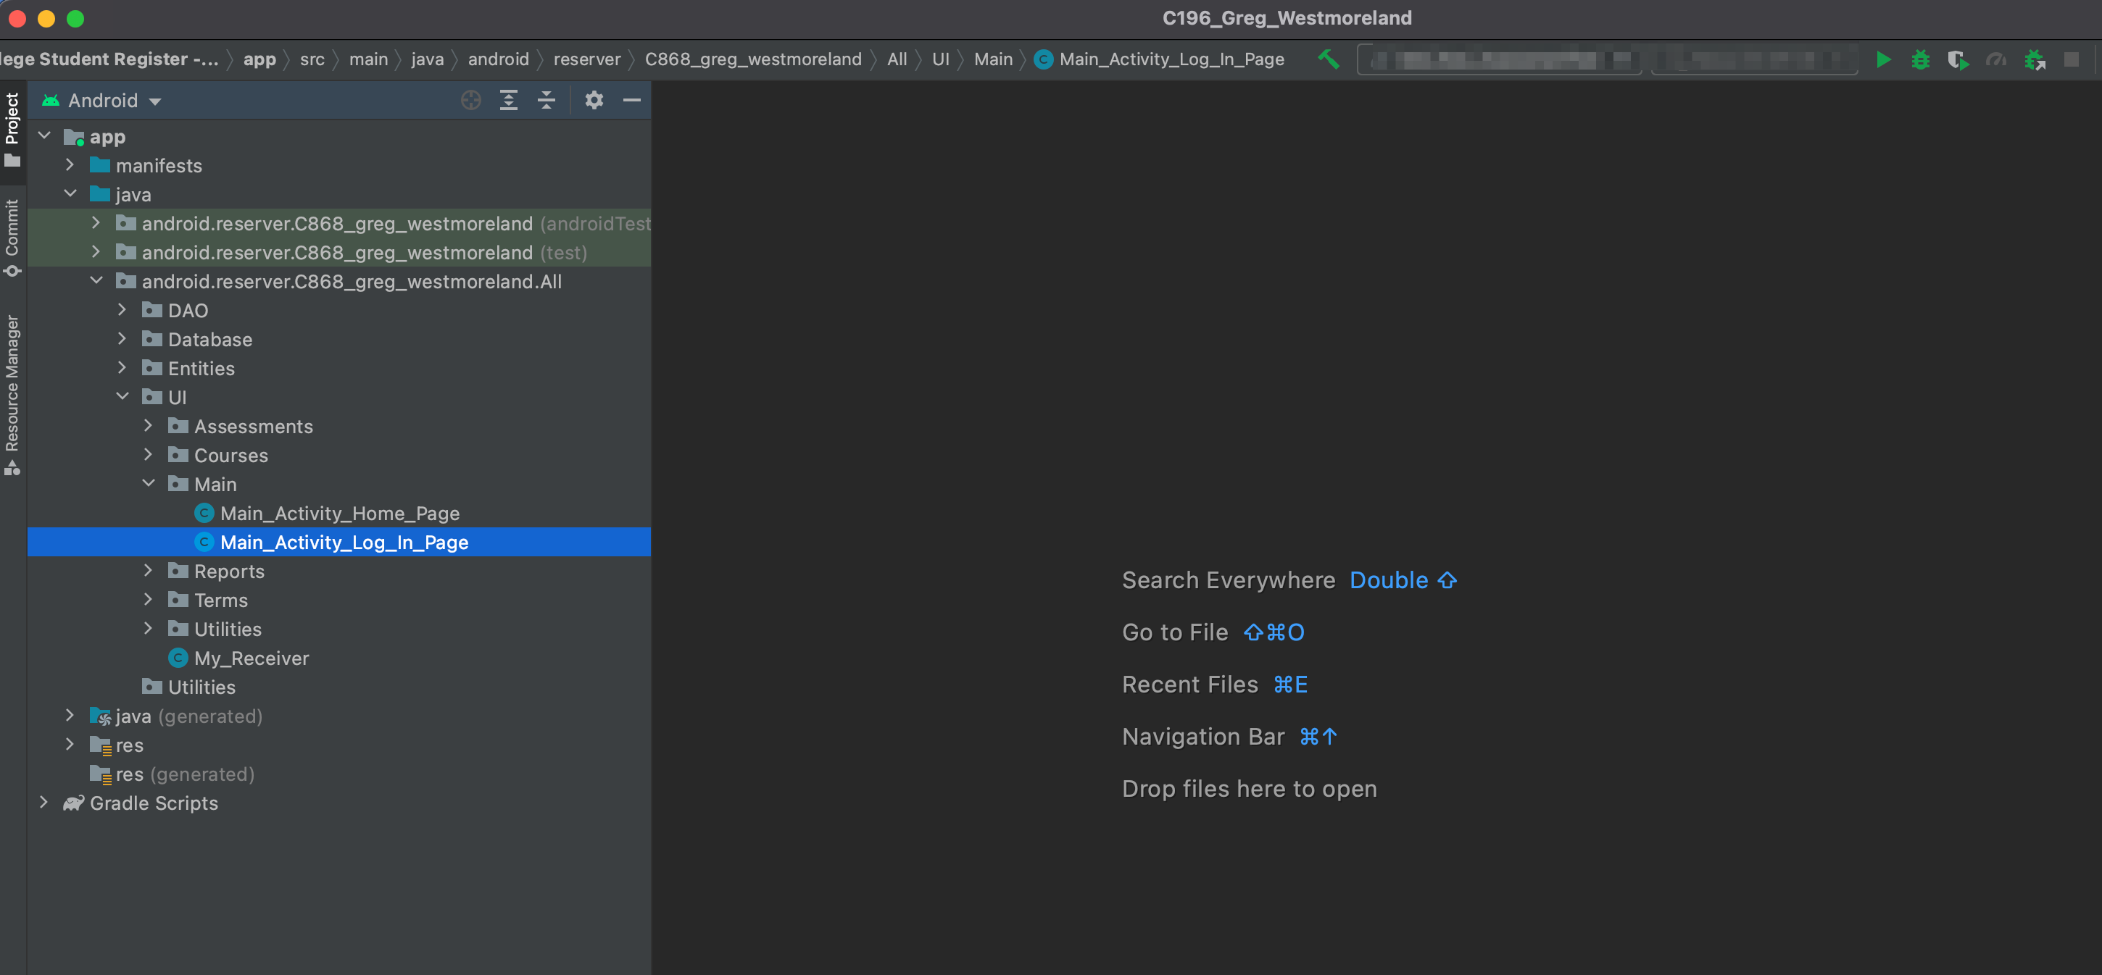

* Next you will set up your emulator.

## Login and Signup (An example)

1. Click the "Log in" button in the top right corner of the app.



1. If you already have an account, log in with your account name and password. If you need an account, click on the link below that states “Need an account?”
2. If you need to create an account, choose a unique username and password. By default, the password requires at least 6 characters. This function could be changed to address new password requirements.

## Classes

### Create a New Class

1. Once logged in, click on the link at the top labeled “Classes”. This will enable you to create a new class of students.



1. Click on “+ Add Class”.

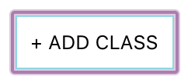

1. Enter a class name and its description. The class name must be unique.
2. Click “Add Class” to add the class, otherwise click “Cancel” or outside of the modal to cancel adding the class.

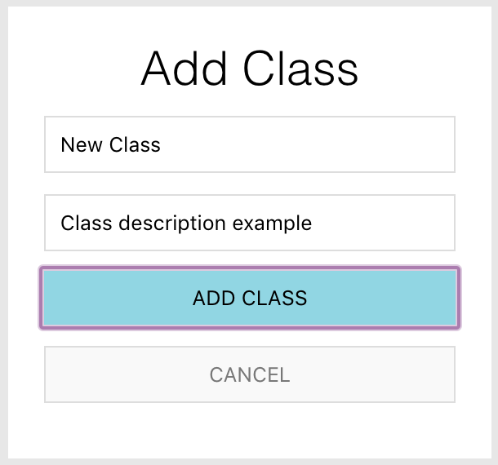

## Reports

1. To access the reporting feature, from the Schedule module, click on “Generate Report” near the top right of the page.

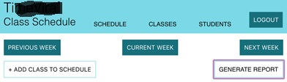

1. 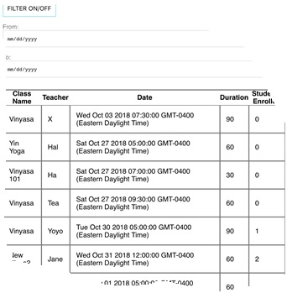By default, all events are generated and displayed.